TECHNOLOGY TRANSFER PLAN

TECAFRICA AND KARIBA ENGINEERING SERVICES LIMITED

Contents

ABSTRACT 3

INTRODUCTION 4

OVERVIEW OF TECAFRICA 4

1.1 PROJECTS IN GHANA 4

1.2 TECAFRICA & KARIBA PROFILE 5

MISSION 5

1.3 TECAFRICA SERVICE OFFERINGS 6

GEOTECHNICAL SURVEY SUPPORT 6

RIG POSITIONING 7

IRM SUPPORT 7

2.0 AIMS AND OBJECTIVES OF THE TRANSFER OF TECHNOLOGY SYSTEM 8

2.1 REASON FOR TRANSFER OF TECHNOLOGY SYSTEM 8

2.11 PEOPLE 8

2.12 PARTICIPATION OF INDIGENOUS COMPANIES 9

2.2 OBJECTIVE FOR KARIBA 9

3.0 USING TECHNOLOGY TRANSFER PLAN TO SATISFY LOCAL CONTENT REQUIREMENT. 10

EMPLOYMENT & TRAINING PLAN 10

Employment Plan 10

Training Plan 11

IN-COUNTRY PROCUREMENT PLAN 12

4.0 TECHNOLOGY TRANSFER PLAN FOR PAST & PRSENT CONTRACTS 13

CONTRACT 4700001093-TULLOW GHANA LIMITED 13

CONTRACT 4300003860-TULLOW GHANA LIMITED 15

CONTRACT SRIEMAS-SC-16-00008-SRI EMAS: 16

TECAFRICA-TULLOW GHANA LTD SUBSEA INTEGRITY SERVICES 16

SCOPE OF WORK FOR TECAFRICA TO EXECUTE UNDER THE CONTRACT 16

5.0 TECHNOLOGY TRANSFER STRATERGIES TO KARIBA 17

PLAN 17

EXPECTED OUTCOME 17

EVALUATION 17

# ABSTRACT

TECAFRICA acknowledges the crucial role a technology transfer plan plays in building the capabilities of Ghanaian companies. As per the Petroleum Local Content and Local Participation Regulation, 2013, (LI2204), TecAfrica is committed to developing local content. This technology transfer plan targets the development of diverse technical, project management and leadership skills to Kariba Engineering Services Limited.

# INTRODUCTION

## OVERVIEW OF TECAFRICA

TecAfrica is a subsea service company providing a wide range of survey, positioning and data management services using the most advanced equipment and techniques. TecAfrica is a member of the Acteon Group of companies with offices in all major energy producing regions worldwide. Via our integrated services approach we leverage the combined strength skill and experience through bundling services of Acteon Group to provide solutions across the life of the field from exploration all the way to the decommissioning. This enables us to support clients with unique skills and technologies thus ensuring technical innovation and service excellence. TecAfrica as company is committed to local development. Development requires human ingenuity. We at TecAfrica recognize that people are the most important resource and we are prepared to play a part in developing this resource. We understand the entire energy value chain and know that oil and gas will continue to play a critical role in the development of people and the country as a whole.

## PROJECTS IN GHANA

TecAfrica is headquartered in Accra has been active in Ghana since 2011. We have worked with Tullow on number of projects such as Project Yellow where we provided temporary mooring installation. TecAfrica has also provided Tullow with SURF support for Jubilee and has also done likewise for ENI with SURF support for OCTP. TecAfrica has also worked hand in hand with Ghana Gas by performing a pre-engineering survey GEL line in 2013.

## TECAFRICA & KARIBA PROFILE

**TecAfrica Offshore Limited (TECAFRICA)** is an incorporated joint venture between **Kariba Engineering Services Limited** (a 100% owned Ghanaian company holding a 10% equity) and **EURWA** (a foreign branch company UTEC holding 90% equity) under the Company’s Code of Ghana to provide technical services in support of Ghana’s upstream petroleum sector. **EURWA** and **UTEC** alongside our parent company **Acteon** have played a crucial part in supporting the JV both financially and technically.

**Kariba Engineering Services Limited (KARIBA)** is a wholly owned Ghanaian company that was established in April 2014 to provide engineering and upstream services for the Ghanaian oil and gas industry. Kariba aims to be the leading local oil and gas company in oilfield services, facilities management, oil field equipment and rental and engineering services.

Kariba is managed by a talented team with excellent knowledge of international and local oil and gas service industry. Management of KARIBA have experience working with global giants such as ReedHycalog, Baker Hughes, Schlumberger and National Oilwell Varco across the globe with a cumulative experience of over 35 years.

## MISSION

To establish and grow a multidiscipline offshore technical services company to support the burgeoning oil and gas sector in Ghana with a focused commitment to transfer of knowledge and expertise towards local personnel and indigenous support services companies.

TecAfrica has leveraged on the technical expertise of EURWA and our sister companies in the Acteon group (including InterMoor, Clarus, Pulse and 2H) to compete for contracts and grow the JV business for the benefit of both partners and the wider Ghana economy.

## TECAFRICA SERVICE OFFERINGS

Through our affiliation with Acteon, TecAfrica provides world-class services in drilling, pilling and grouting for subsea foundations. We provide flexibles solutions across the life of a field from exploration all the way through to decommissioning. TecAfrica provides cutting edge technological support for Geotechnical & Geophysical, Rig Positioning and IRM Support

Figure 1

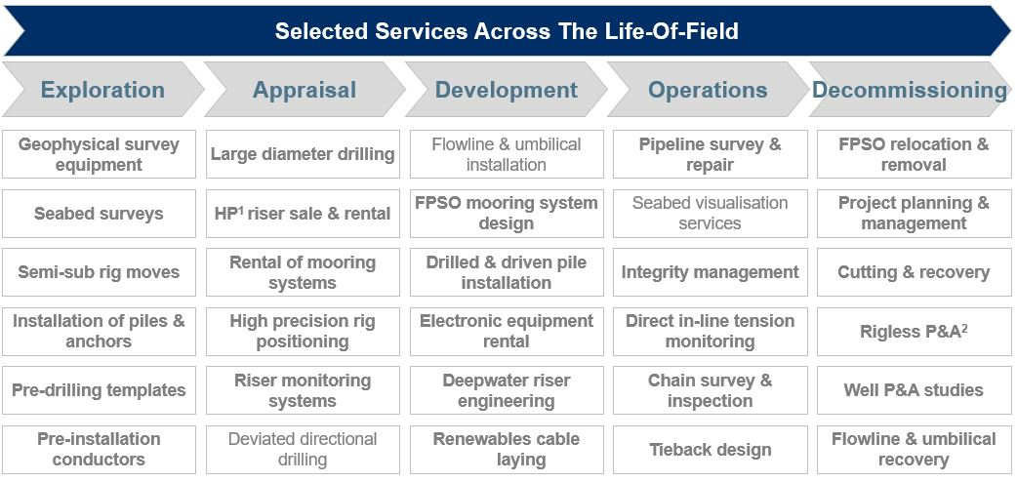

GEOTECHNICAL SURVEY SUPPORT

We provide specialist geotechnical survey tools and support, providing site analysis, throughout a project lifecycle, to ensure the long-term performance of offshore assets.

TecAfrica provides specialist geotechnical survey support through the geoROV™ tool, an ROV based shallow CPT & Coring system which has been used in very close proximity to existing seabed assets and even underneath structures. We also support standard GI operations and have access to a number of geotechnical tools including CPT units and Corers.

Furthermore, we utilise Vessel mounted MBES (Multi-Beam Echo-Sounder) & SBES (Single-Beam Echo-Sounder), Towed SSS (Side Scan Sonar), SBP (Sub-Bottom Profiling), Magnetometer USBL (Ultra-Short Baseline) tracking for various Geophysical surveys such as Reconnaissance Surveys and AUV Surveys

RIG POSITIONING

Real-time navigation systems are used to execute successful rig moves, generating coordinates and positioning updates using Global Positioning Systems (GPS) and rig headings using gyro equipment. These technologies interface with our navigation software to produce real time viewing of a rig move.

Our telemetry systems allow for instantaneous communication and tracking of support vessels as well as precise anchor positioning on the seabed. Acoustic transponders may also be employed to facilitate rig moves.

IRM SUPPORT

We have online and offline survey systems that interface with and provide data feeds to conventional vessel and ROV (Remotely Operated Vehicle) based inspection campaigns. We perform acoustic pipeline inspection using vessel and AUV (Autonomous Underwater Vehicle) mounted sensors.

Figure 2

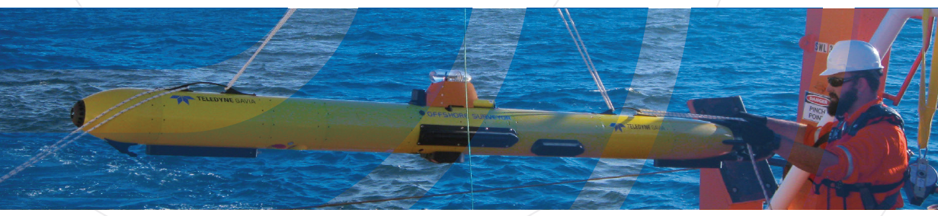

# 2.0 AIMS AND OBJECTIVES OF THE TRANSFER OF TECHNOLOGY SYSTEM

As a multinational oil and gas company operating in Ghana, TecAfrica has a strong policy to localize our operations as much as possible. This intended to bring significant benefits to TecAfrica in a number of areas and allow the company to be competitive from a cost perspective and integrate into the local economy. Our technology transfer plan is based on people having training / practical hands on experience and taking them through learning programs.

## 2.1 REASON FOR TRANSFER OF TECHNOLOGY SYSTEM

In support of developing local capabilities and skills, TecAfrica recognizes the important role of people and organizations most especially as it relates to the technology transfer required in the Petroleum Local Content and Local Participation Regulation, 2013, (LI2204).

### 2.11 PEOPLE

TecAfrica’s in country-employment and development programs are based on these fundamentals:

* **TRAINING:** We aim to have an impact on Ghanaians by providing a platform for people to improve their skillset by providing practical training, taking them through training courses, workshops and seminars using expert personnel from Acteon’s network.
* **LEARNING PROGRAMS:**  A program will be put in place for selected employees to gain exposure and experience abroad. They will be sent to locations such as Houston (United States of America), Aberdeen and London (United Kingdom) to work on technical projects to gain a practical understanding. Such assignments will enable best practice sharing, effective skills transfer and also to network across the broader Acteon organization.

### 2.12 PARTICIPATION OF INDIGENOUS COMPANIES

TecAfrica will prioritize the use of local companies in all possible aspects of in-country operations. This will be a main focus area in our localization activities. There are certain services which can readily be procured from existing indigenous suppliers. For those goods which are not currently readily available from local suppliers, TecAfrica will seek to implement partnerships with certain indigenous companies to support their development with the aim of building capacity and capability to the level required by the Oil & Gas industry.

## 2.2 OBJECTIVE FOR KARIBA

TecAfrica’s technology transfer plan focuses on developing diverse technical, project management and leadership skills applicable in the oil & gas industry. This will be done to give an individual both the skillset and the understanding to operate in the Oil & Gas industry. As part of the technology transfer plan we aim to enable Kariba grow in these three key areas:

* Operations
* Oilfield Services
* Procurement

# 3.0 USING TECHNOLOGY TRANSFER PLAN TO SATISFY LOCAL CONTENT REQUIREMENT.

TecAfrica’s localization programs and plans are built around two main points. These programs and plans are geared towards developing indigenous capacity and capabilities to support in the implementation of its projects.

* **EMPLOYMENT & TRAINING PLAN:** Under this there will be an Employment Plan aimed at having a structure to build-out a local workforce to support local execution and also a Training Plan focused on building the capacity of the country’s local workforce.
* **IN-COUNTRY PROCUREMENT PLAN:** Where good and services can be used to carry out a task, Kariba will help TecAfrica in sourcing such goods and services.

## EMPLOYMENT & TRAINING PLAN

### Employment Plan

TecAfrica’s aims to enable a local workforce to gradually undertake projects through hands on work and training. The total number of people recruited shall be dictated by project requirements. We are headquartered at Airport City and currently being manned by technical sales engineers that are assisting on current projects. We also intend to recruit surveyors, engineers and accountants locally to aid in upcoming projects. This is done with the intention to fully hand over operations in years to come to help develop local content and reduce cost. The table as depicted shows our plan for the localization of jobs. Currently TecAfrica’s is being aided in their operations by their local partners Kariba.

Table 1

|  |  |  |  |
| --- | --- | --- | --- |
| **Stage** | **National Positions As % Of Your Total Positions** | **Nationals – Senior Management As % Of Your Total Senior Management Positions** | **Nationals – Supervisory Positions As % Of You Total Supervisory Positions** |
| Commencement | 50% | 50% | 100% |
| End of 1st Year | 50% | 50% | 100% |
| End of 2nd Year | 80% | 50% | 100% |
| End of 3rd Year | 88% | 50% | 100% |

Below is the estimate of local employees required to support growth of the company:

* 2 Ghanaians Employed by The End of 2018 (Target Achieved)
* 4 Ghanaians Employed by The End of 2019
* 8 Ghanaians Employed by The End of 2020

### Training Plan

We are committed to providing ample opportunities for local talent development and employment. For a selection of positions, high potential local nationals will be appointed to become deputies of specified expatriates for a set period of time. During that period these locals will start a very detailed development plan. The development plan will include tailored technical training, professional skills, management training, and assignments abroad, and on the job training with the expatriate that they are assigned to. The local employees will gradually take over responsibilities of the expatriates, becoming fully competent to take the position at the end of their assignment.

TecAfrica along with our partner UTEC will invest in a remote training tool to further support our ability to train and support our staff when located far from our core regional offices through the deployment of the UTEC Virtual College (UVC).

This is an especially useful tool for our intended Ghanaian field staff as they progress through our comprehensive development programme to ensure the best possible opportunities for upwards career progression.

## IN-COUNTRY PROCUREMENT PLAN

TecAfrica is committed to develop its local content footprint wherever possible and to grow this commitment to invest in the Ghanaian people, goods and services as our business itself grows. Wherever possible we will source locally and will approve local vendor process in line with our group procurement best practice. We are committed to creating an avenue for opportunities locally for indigenous companies in accordance with LI 2204. Also, in accordance with regulation we have developed a procurement plan that we share with the Petroleum Commission on a quarterly basis. This plan gives a detail look at the different procurement scopes required and the various timelines associated with it.

# 

# 4.0 TECHNOLOGY TRANSFER PLAN FOR PAST & PRSENT CONTRACTS

Table 2

|  |  |  |  |  |
| --- | --- | --- | --- | --- |
| **Client** | **Contract Number** | **Contract Description** | **Status** | **Effective Date** |
| Tullow Ghana Limited | 4700001093 | Framework Agreement for Engineering and Technical Assistance Services for Flexible (Risers, Flowlines and Jumpers) Technologies – Ad hoc consultancy support. | Completed | 9th May 2017 |
| Tullow Ghana Limited | 4300003860 | Provision of Temporary Spread Mooring Installation Services Offshore Jubilee field. | Completed | 12th Nov 2016 |
| SRI EMAS | SRIEMAS-SC-16-00008 | Provision of Survey Services on board Client provided vessels. | Completed | 2nd Mar 2017 |

The table below shows a list of projects executed by TecAfrica.

## CONTRACT 4700001093-TULLOW GHANA LIMITED

Under the Framework Agreement for Engineering and Technical Assistance Services for Flexible Technologies, TecAfrica provided practical training for local offshore staff within a 12-month span. The table below shows the scope of our training.

Table 3

|  |  |  |  |
| --- | --- | --- | --- |
| **Type of Training** | **Specifics for Program** | **Duration** | **Performance Indicators** |
| On the Job Training | Offshore Surveyor  Extensive time spent offshore working closely with Senior Offshore Surveyor and learning the operation of the role. | 6-12 months | * Ability to understand the main elements Geodesy, surface positioning systems and subsea acoustic positioning. * Perform online working 12 hour shifts and maintaining all online systems to the satisfaction of the Senior Surveyor. * Troubleshoot issues with both online and subsea positioning systems. |
| Academic | Ongoing competency-based training and assessment to develop skills needed in the role and to develop to the role of Senior Offshore Surveyor. | 12 months | Complete IMCA Competency Scheme for Surveyors, audited by UTEC. https://www.imca-int.com/divisions/survey/personnel/ |
| Formalized Training Courses | Basic Offshore Survival Safety Training.  Instructor led  training to  develop more  detailed technical  understanding  and allow  technology  transfer training  to the employee  for future  development in  the Oil and Gas  Industry  understanding  and allow  technology  transfer training  to the employee  for future  development in  the Oil and Gas  Industry | 1 week | Complete Basic Offshore Safety  Induction and Emergency Training  course (BOSIET)  UTEC new employee training  program  NaviPac Offshore Survey Software  training  Sonardyne 6G subsea Positioning  system training course |

## CONTRACT 4300003860-TULLOW GHANA LIMITED

Our sister company InterMoor’s patented SEPLA (Suction Embedded Plate Anchor) system was used exclusively on the installation of the temporary spread mooring installation for the Kwame Nkrumah FPSO on the Jubilee field offshore Ghana for Tullow Ghana Ltd in 2016.

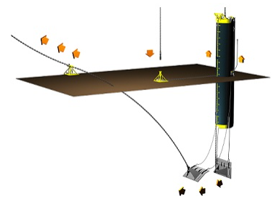

When InterMoor introduced its patented SEPLA (Suction Embedded Plate Anchor) system in 1997, it was a revolutionary concept in Deepwater mooring: the combination of two proven anchoring concepts—suction piles and plate anchors—to increase the anchor point efficiency of pre-set moorings and reduce mooring system costs for floating structures.

Today, that pioneering concept is proving its remarkable value in Deepwater scenarios around the world. TECAFRICA employed and trained 4 Ghanaian Riggers to support the project offshore and gain competence in this bespoke anchoring solution as well as gaining valuable experience in a complex offshore engineering project. On completion of the project those local riggers have gained competence and track record in offshore mooring that can be used on future projects in Ghana and around the world. This investment by TECAFRICA and transfer of technical knowledge provides us with access to skilled local capability for future offshore projects

## CONTRACT SRIEMAS-SC-16-00008-SRI EMAS:

TECAFRICA were contracted by SRI EMAS (Indigenous Ghanaian Offshore Contractor) to support the offshore installation of the OCTP (Offshore Cape Three Points) oilfield offshore Ghana for ENI in 2016. As part of our local content commitment TECAFRICA employed 3 local offshore surveyors to support offshore operations and gain valuable offshore training and experience on

Following completion of this project these individuals have gained technical competency in offshore field development support and also worked to the highest standards of our QHSE processes and procedures. This investment by TECAFRICA and transfer of technical knowledge provides us with access to skilled local capability for future offshore projects.

## TECAFRICA-TULLOW GHANA LTD SUBSEA INTEGRITY SERVICES

The objective of the work is to perform a gap analysis of Tullow’s existing subsea integrity management (IM) activities on the **Jubilee field** to demonstrate the value of implementing an integrated integrity services model and provide the details to develop a broader services proposal.

### SCOPE OF WORK FOR TECAFRICA TO EXECUTE UNDER THE CONTRACT

* Design, Fabrication, Installation and Operations (DFIO) asset register;
* Risk assessment and integrity management plan (IMP);
* Inspection work scopes and Key Performance Indicators (KPI) development;
* Anomaly identification, assessment, tracking and close out process;
* Annual health status report and feedback into IM plan.

As part of our joint-venture affiliation with Kariba. Kariba will provide TecAfrica the following support under the contract. They are namely:

* Operational Support
* Oilfield Services

# 5.0 TECHNOLOGY TRANSFER STRATERGIES TO KARIBA

## PLAN

The following approach will be taken for the development of Kariba personnel:

* Kariba will be offered to participate in Acteon training programs.
* Selected staff from Kariba will be offered technical training to specific Acteon companies.
* Kariba will be offered online training programs.
* Kariba will be tasked to perform task in the technology transfer plan in line with project’s requirements.
* Kariba staff will be offered exposure in operations.
* Kariba will be tasked to help in the sourcing of goods and services.

## EXPECTED OUTCOME

* Kariba is be able to perform tasks designated to them effectively and efficiently.
* Kariba is able to procure goods and services properly with short lead time.
* Kariba gains the expertise to independently tender, win and execute contracts.
* Kariba to become the leading Ghanaian Oilfield Service company.

## EVALUATION

* Periodic performance reports.
* To hold a feedback session with the Petroleum Commission to share lessons learned with the course of that year.
* Having periodic monitoring and evaluation visit by the Petroleum Commission local content team to have a first hand feel of the transfer of skills and technology.
* To have a framework developed for key skills and competencies with clear milestones /progress indicators identified for core areas – short, medium- and long-term targets.